Problem 1 Report File

Alex Helfrich

CS 3304 Section 04

1/23/17

For problem 1.1 I created a class called IntSum that would take a positive integer from the user and display the sum of the first N integers.

Machine generated alternative text:
PS C: 3304\prob1em TempConv. cpp 
PS C: 33Ø4\prob1em . \TempConv.exe 
-o TempConv. exe 
Enter the temperature in 
elsius 20 is Fahrenheit 
Enter the temperature in 
Fahrenheit 68 is Celsius 
Celsius: 20 
degree 68 
Fahrenheit: 68 
degree 20 

For problem 1.2 I created a class called GeoAreas that shows the area of all the polygons with side lengths 1-6. I did so by creating several methods, one for each polygon, and one special method called regPolygon() that the pentagon, hexagon, heptagon, and octagon methods would use.

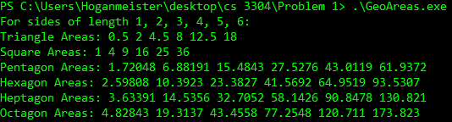

For problem 1.3 I created a class called Time that simply uses the time() method included in the ctime class to display the time in seconds.



For problem 1.4 I created a class called AdditionTime that records the time before randomly generating 100000 positive integers using the rand() method and adding them together, then taking the time again. By subtracting the second time by the first time that I took, I displayed the result.

